Default Settings – Palletizing:

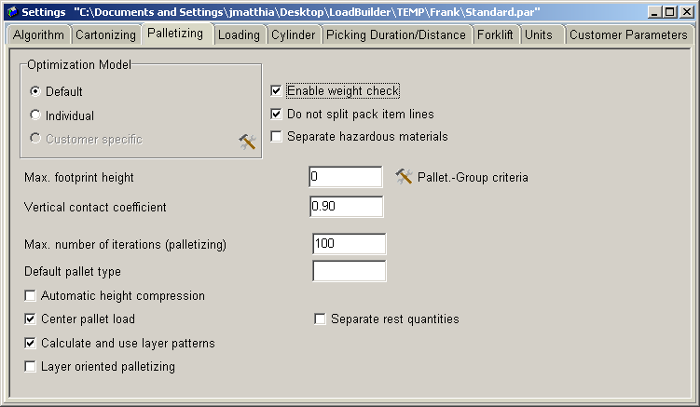

Used to configure specific palletizing settings.

Relevant fields:
Enable weight check: Make sure this is checked to enforce weight.

Do not split pack item lines: Do not split item lines across pallets.

Vertical contact coefficient: is a decimal percentage of the surface area needed to stack items on top of each other. If bottom item is 11 x 11 and top is 12 x 12 then <vertical coefficient> * 12x12 >= 11x11

Max. number of iterations (palletizing): Maximum number of iterations to go through while attempting to build a pallet.

Calculate and use layer patterns: Tries to calculate layer patterns and use them.

